Instructions to run the code:

**Hardware:**

Any windows 64 comfortable computer Machine with RAM, ROM & Highly effective CPU.

**Software:**

Code Blocks, Windows 10 OS, .txt files, file reader and writer.

**Language:**

C Programming language.

* We need some files which are named and placed on same location as shown below: **C:/test/adhaar.txt, C:/test/newentry.txt, C:/test/transferrecord.txt.**

Report:

1. Introduction:

This project is very useful to poor peoples who is unable to pay their hospital bill. our system will calculate how much amount of money they need to get from government as subsidy benefits based on their asset value.

We will calculate Asset value from the Aadhar card and Pan card of the person. By means of -> (As we all know that now a days every Asset value including land, money, house etc., are linked to either Aadhar card or PAN card).

b) Problem statement:

Financial health care system. In this, You need to calculate how much amount of money did a particular person get from government as subsidy for a hospital bill. It depends on the assets added to their Aadhaar or pan card.

**Input:**

Aadhar or pan card number**.**

**Output:**

The amount of money and percentage of money get by govt. as suicided.

c) How your project solves the problem:

* If we have Aadhaar or pan card details of the user. We can find the amount of money and percentage of money they get from govt. as subsidy. If we did not have the Aadhaar or pan card details of the user, we record the phone number and Aadhaar number in the separate file and we will contact him/her after checking the records of the govt.
* Subsidy money is depending on properties added to the Aadhaar or pan card.
* If the properties are more, we will give less amount of money for hospital bill. If the properties are less, we will give more amount of money for hospital bill.

**Calculation:**

**Percentage= [(amount of hospital bill/properties added to Aadhaar or pan card) X 100].**

Algorithm:

**Flow chart**

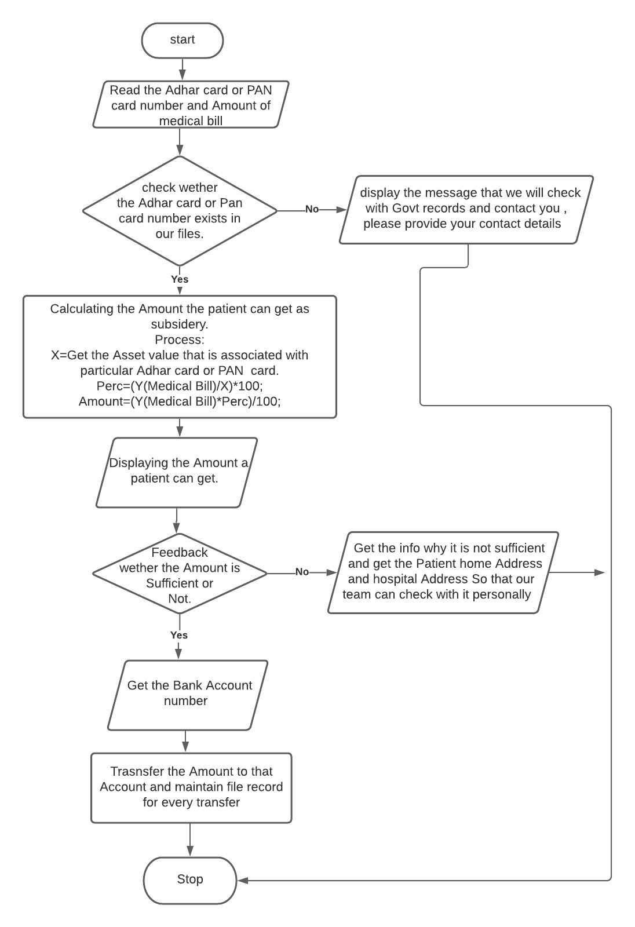

Screenshot of output:

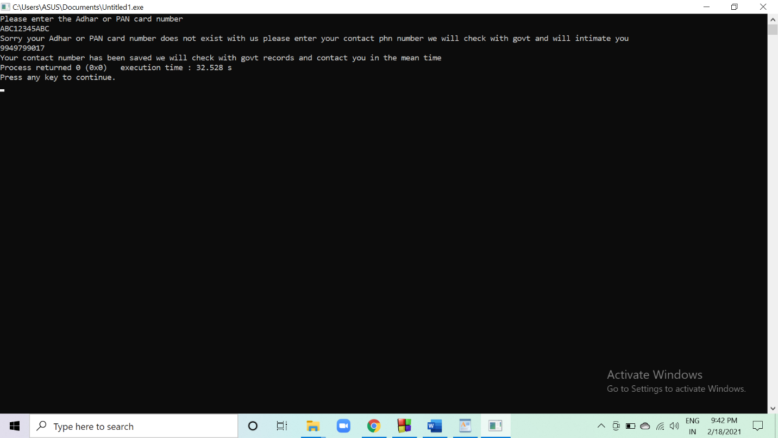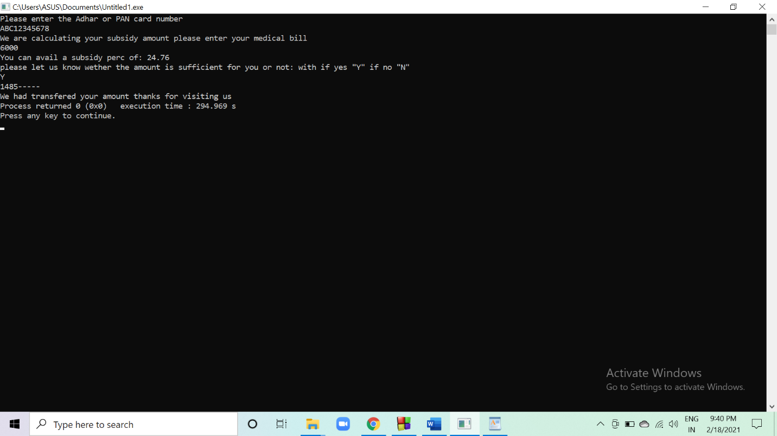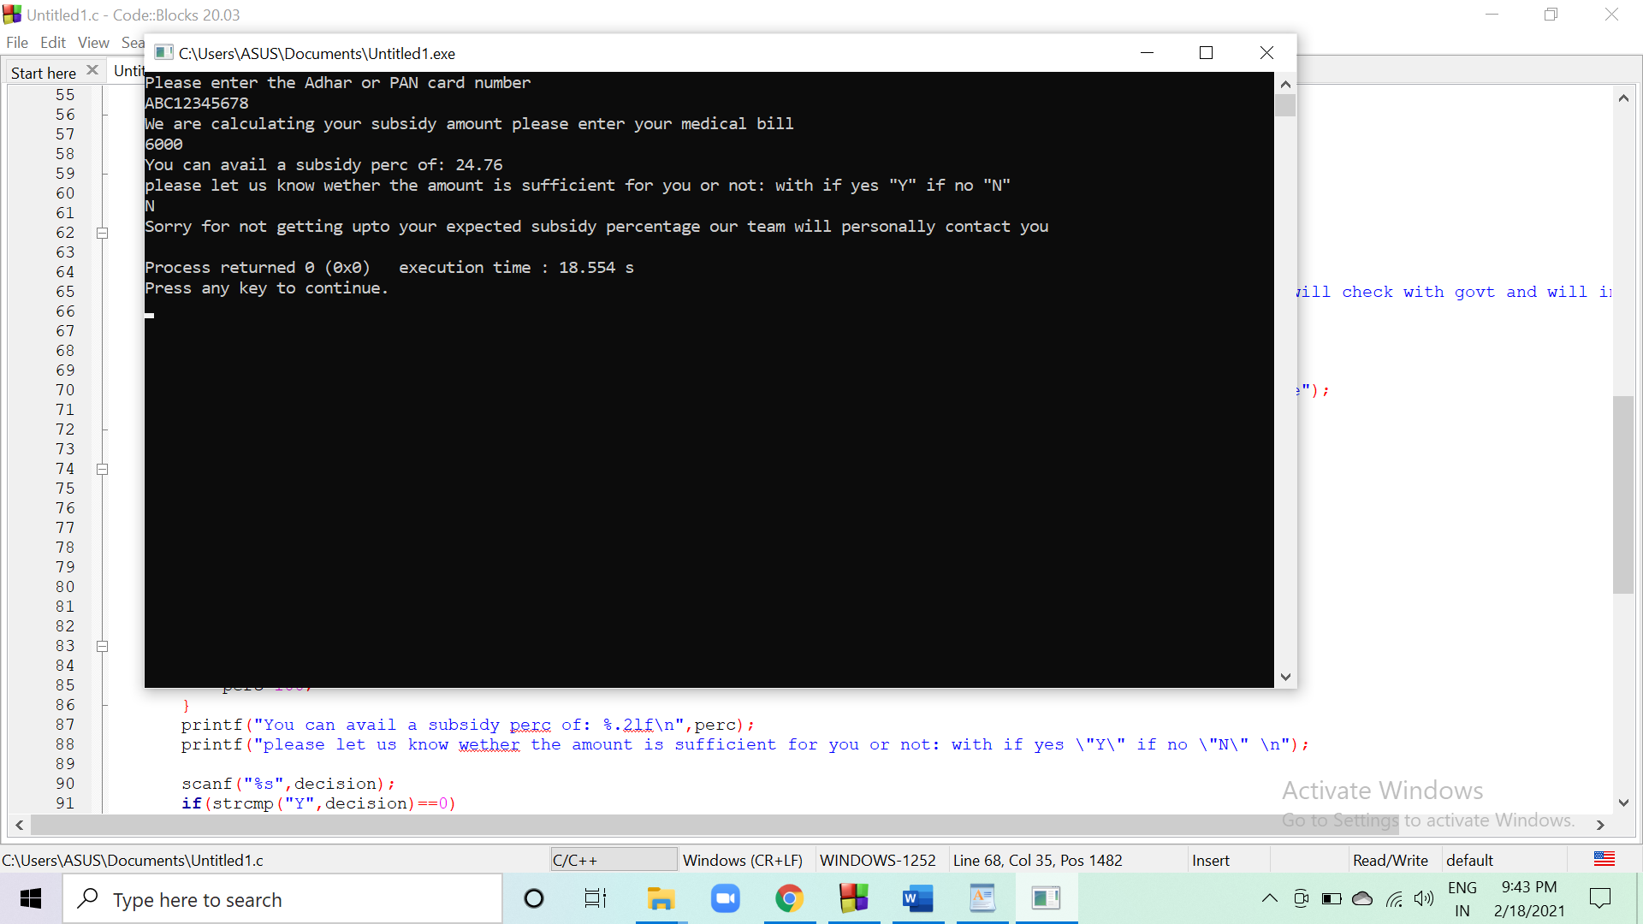

Conclusion:

At last of the project, we will conclude the amount of money we get as subsidy from the government for a particular person and we learn the file handing topic by this project which is more important in future.

Future prospects:

In future it is very useful to poor peoples. who are not able to go for higher level of hospital’s by not have sufficient money to pay bill, for those it is very useful in future.

Reference:

* <https://www.programiz.com/c-programming/c-file-input-output>
* <https://www.tutorialspoint.com/cprogramming/c_file_io.htm>
* <https://www.programiz.com/c-programming/examples/write-file>
* <https://stackoverflow.com/questions/3889992/how-does-strtok-split-the-string-into-tokens-in-c#:~:text=strtok()%20divides%20the%20string,and%20end%20with%20%22%2C%22>.
* <https://www.tutorialspoint.com/c_standard_library/c_function_strtok.htm>
* <https://www.educative.io/edpresso/splitting-a-string-using-strtok-in-c>
* <https://stackoverflow.com/questions/23839971/how-to-read-specific-value-from-file-in-c>